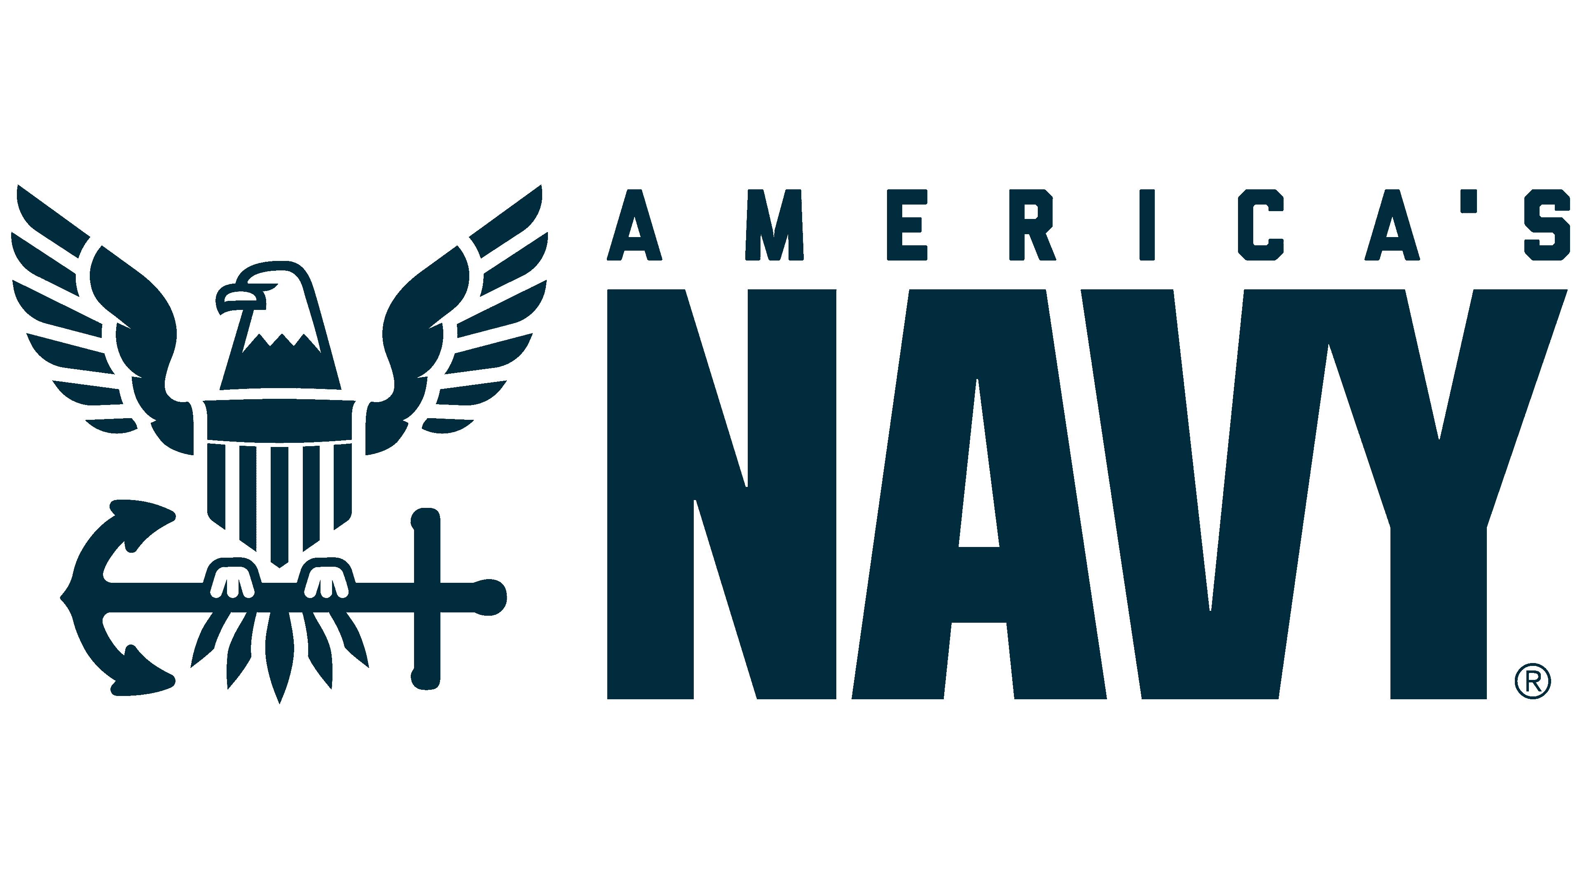

**Commander XXXXX X XXXX**

**Supply Corps, United States Navy**

**Detailer, Office of Supply Corps Personnel (PERS 4412)**

Commander XXXXX XXXX is a native of Millington, Tennessee. He graduated from the University of…..

Operationally, CDR XXXX served as….

Ashore, CDR XXXX….

CDR XXXX is a qualified Naval Aviation Supply Officer….

*Updated: Apr 2025*